Cracker Barrel

1047 Executive Dr

Elizabethtown, KY

2021 Michelin NCM Bash

Wednesday 4/21 – Saturday 4/24

Bardstown

# Maker's Mark Distillery

3350 Burkes Spring Rd, Loretto, KY 40037

(270) 865-2881

Burks Spring Rd

Makers

Mark

Distillery

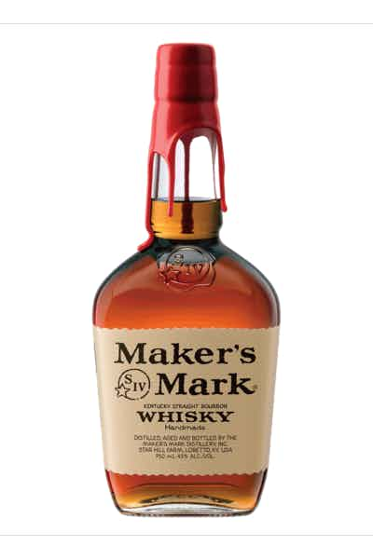

49

Bluegrass Parkway

**National Corvette Museum**

**Itinerary**

**Wednesday 4/21 – Drive to hotel**

Pick up registration materials

Dinner

**Thursday 4/22**

Trip to Makers Mark

Dinner

**Friday 4/23** – Bash Day

MSP Touring Laps 8am – 12pm

MSP Touring Laps 1pm – 5pm

Museum/Store

Dinner

**Saturday 4/24** check out of hotel

Classroom w/ Paul Koerner C8 8:30am-10:30am

Federal Grove lunch 11:00am –

Drive home

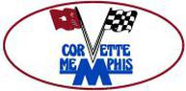

**NCM MOTORSPORTS PARK  
505 KIMBERLEE A. FAST DRIVE  
BOWLING GREEN, KY 42103**

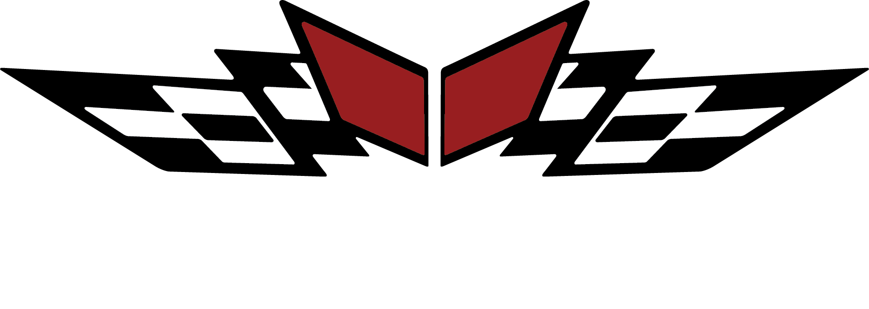

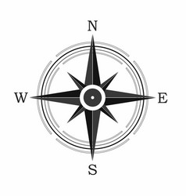

Loretto

52

New Haven

Cave

City

31 E

31 E

31 W

I-40

Corvette Drive

I-65

Exit 28

I-65

I-40

385

National Corvette Museum  
350 Corvette Dr.  
Bowling Green, KY 42101

**Phone:** 270-781-7973

# MainStay Suites

[554 Corvette Drive, Building A, Bowling Green, KY, 42101, US](https://www.choicehotels.com/#hotel-map)

Phone (270) 904-9400

