**Itinerary**

**Saturday 10/2** Drive to hotel

Racetrack events - lunch

Dinner

**Sunday 10/3** Race Day

Be at track 8:00am

Talladega Garage Experience

Yellawood 500 event

**Monday 10/4** Drive home

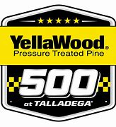

Talladega

Superspeedway

To Talladega Superspeedway

Take 20 to AL 77, exit 168, turn right

At Speedway Blvd, turn left to track

To Hotels:

385 East to 269 South

Exit 269 onto 22/78 East

Exit 22 East onto 65 South

Exit 65 at exit 261A for Hampton Inn

Left onto Rev Abraham Woods Jr Blvd

Right onto 20th St

Left onto Park Place

Exit 65 onto 20 East for Comfort Inn

Exit 20 at exit 132B

Right onto Montevallo Rd



20

Reverend Abraham Woods Jr Blvd

20th St

Exit 261 A



**October 2-4, 2021**

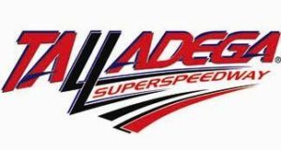

Comfort Inn

4965 Montevallo Rd

205-957-0084

AL 77

Exit 168

Hampton Inn/Suites

2021 Park Place

205-322-2100

Speedway

78

78

**Comfort Inn**

Montevallo Rd

Exit 132 B

Park Place

Richard Arlington Jr Blvd

**Hampton I/S**

20

20

65

269

65

22

385