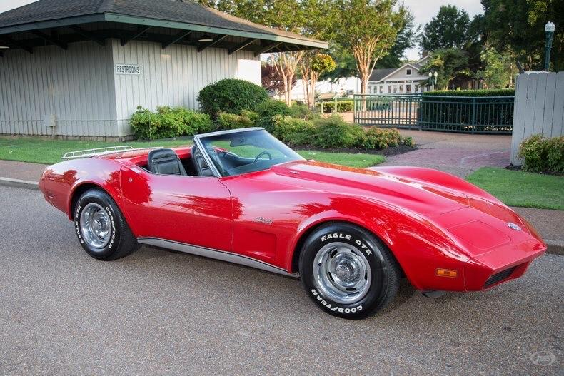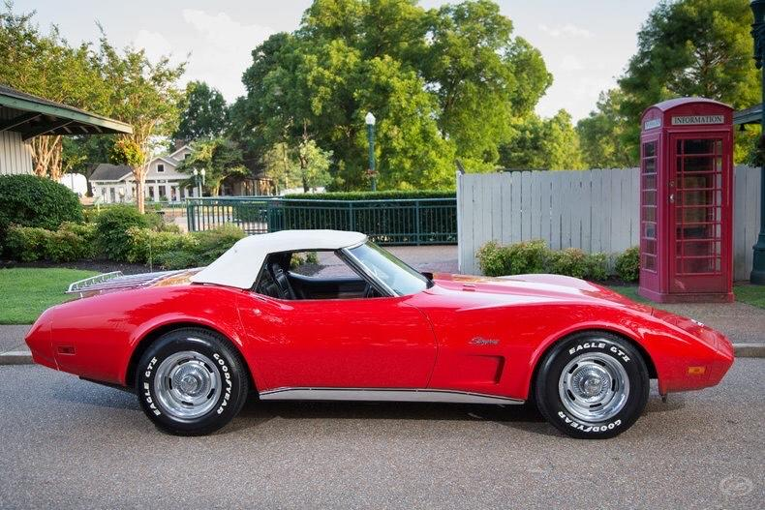
Car info: 1974 corvette, red convertible with both tops. 454 cu in motor. Automatic transmission. Leather interior. 37,764 miles. Car is in Lakeland.
Contact: Sopheary Le 901-338-6544. Friend/owner 901-4865-4436.

