

Vettes at the Beach

10

10

110

Alt 90

45

10

65

65

65

158

45

22/78

269

385

Pensacola Beach, FL

September 16-19, 2021

269

BP

525 Byhalia Rd

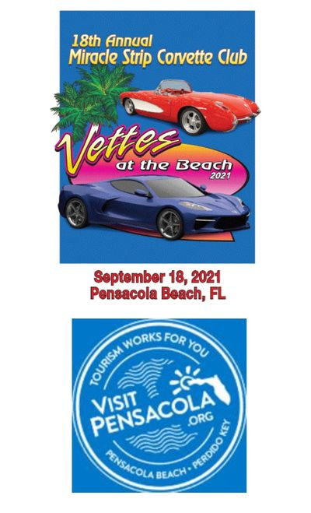

**Itinerary**

Meet at Macy’s – Carriage Crossing Mall 8:00am Depart 8:30am

Pick up stop at BP station. 22/78 at Byhalia Rd (309)

Depart BP at 9:15am.

Pit Stop #1 at Exxon West Point in West Point MS.

Lunch at Magnolias @ the Ritz – just down east from the Exxon station on Main St. 621 Commerce St 11:00am

Pit Stop #2 is at Shell Station 6477 Dale Dr. Marion MS

Pit Stop #3 is Citronelle Country Breeze – Shell located at 19265 N 3rd St (US 45) in Citronelle AL

Pit Stop #4 Shell station 700 Bayfront Pkwy, Pensacola

Hampton Inn – 2 Via De Luna Pensacola Beach

Dinner – Flounders Chowder House, 800 Quietwater Beach Rd, 6:00pm

45

Shell

Exxon West Point

25825 W Main St

Main St

Texaco

Magnolia’s @ Ritz

621 Commerce St

Shell

6477 Dale Dr

Marion, MS

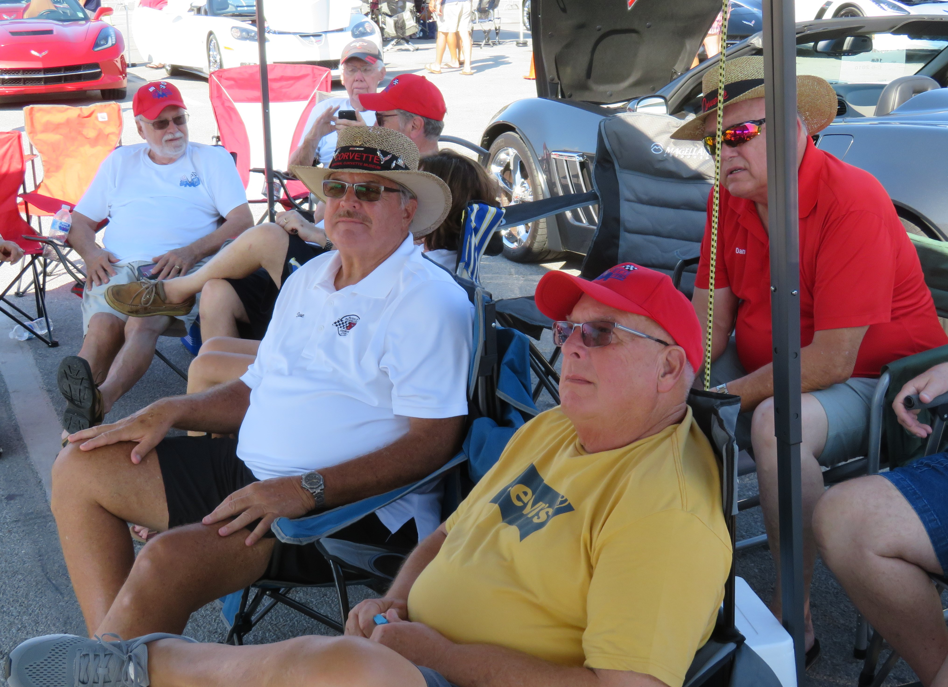

Citronelle Country Breeze

19265 N 3rd St (45) Shell

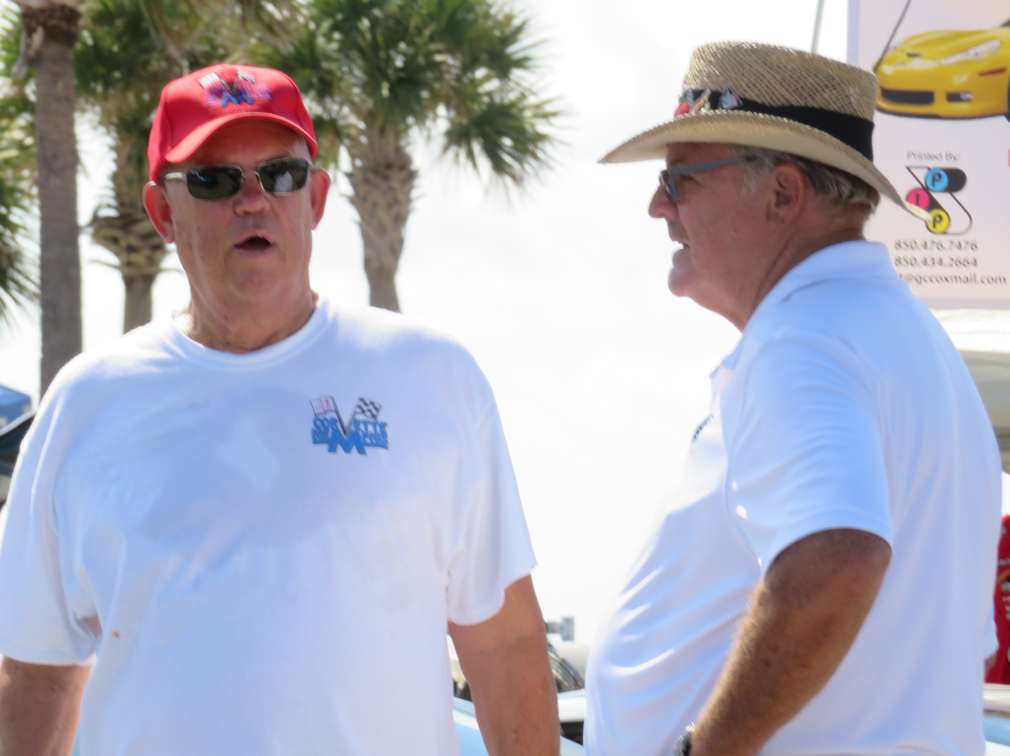

Bring your chairs

Bring your lotion

Bring your vette &

Bring your good time

Alt 90

165

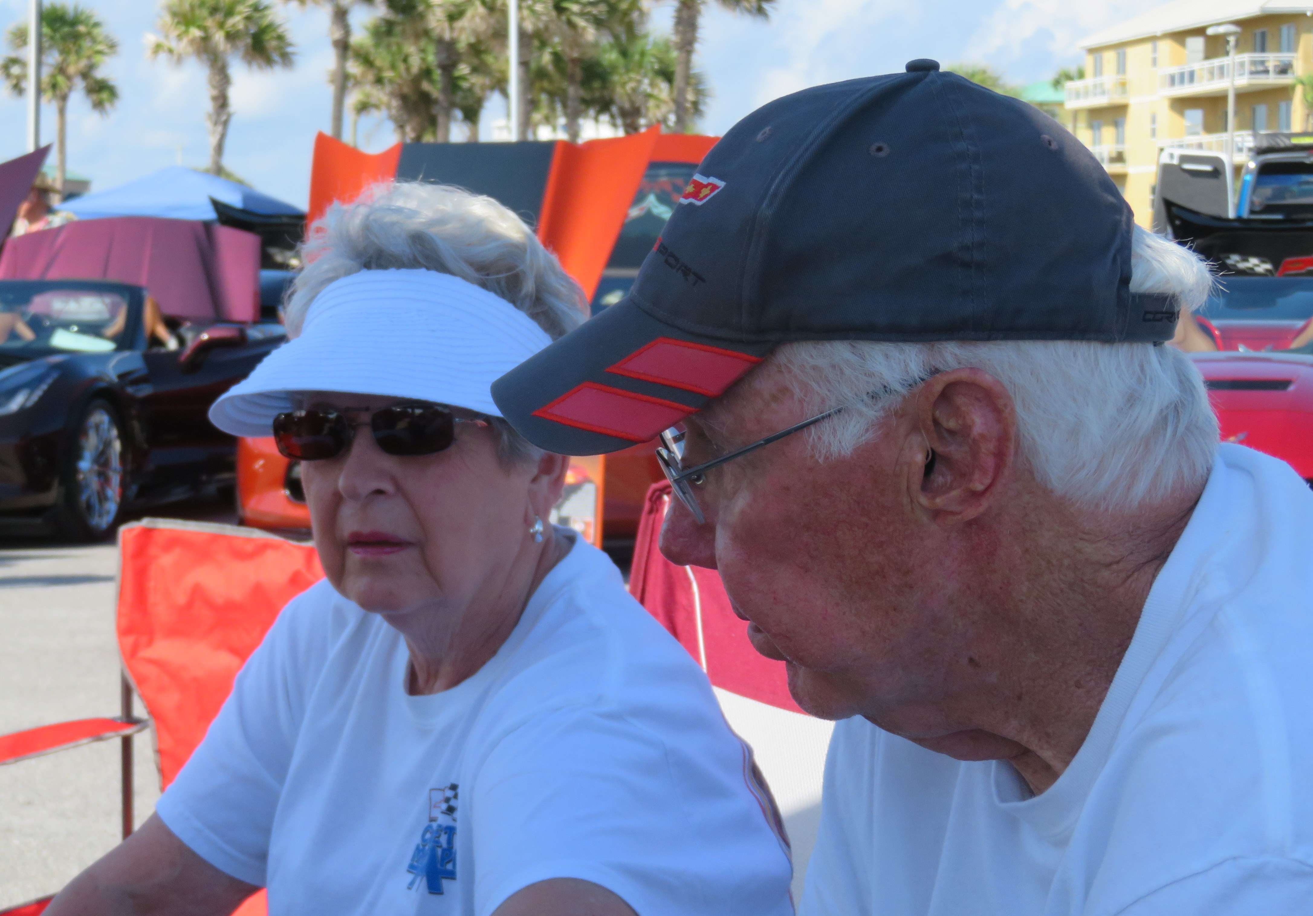

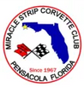

98

Shell

700 Bayfront Pkwy

98

Peg Leg Pete’s

1010 Ft Pickens Rd

Flounders Chowder House

800 Quietwater Beach Rd

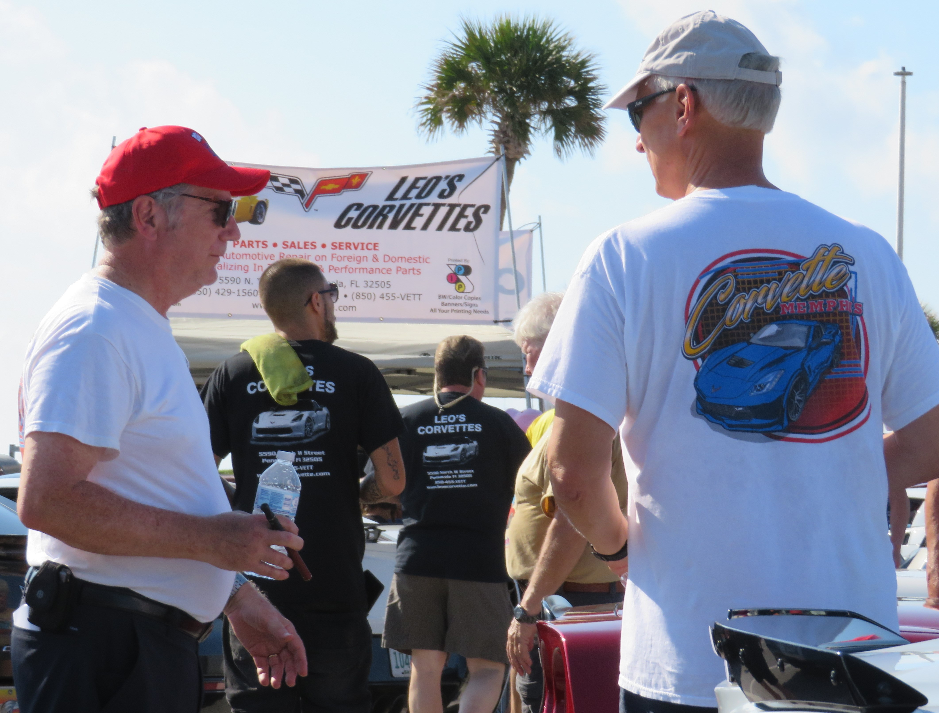

Rev. 9/9/2021

Ft Pickens Rd

Via De Luna

Hampton Inn

2 Via De Luna

850+932-6800

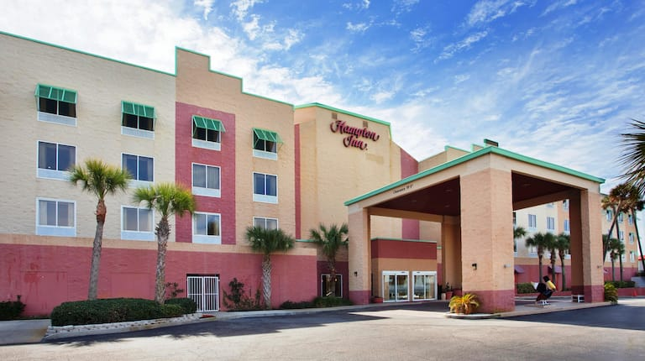

Pensacola Bch Rd