Byhalia Rd

**Itinerary**

Meet at Covenant Baptist Church

10:00am. Leave 10:30am

Drive to Fayette County Airport

Food trucks will be available. We will supply soft drinks & water.

Airshow at 4:00pm. Bring a chair.

Corvette Memphis awning will be set up for shade.

**Driving Route**

Houston Levee to Frank Rd. Frank to Byhalia Rd

Byhalia Rd to Shelton Rd to Collierville Arlington

Collierville Arlington to Macon Rd. Macon Rd to 195 to Fayette County Airport entrance.

Rossville Rd

194

Rossville Rd

Shelton Rd

Poplar Ave

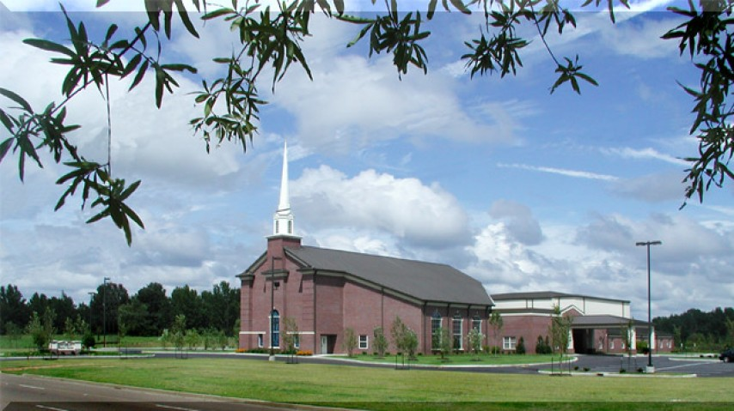

Houston Levee Rd

**Covenant Baptist Church**

**3170 S Houston Levee Rd**

Collierville Arlington Rd

Frank Rd

Wolf River Blvd

Saturday September 25, 2021

*Fayette County Airport*

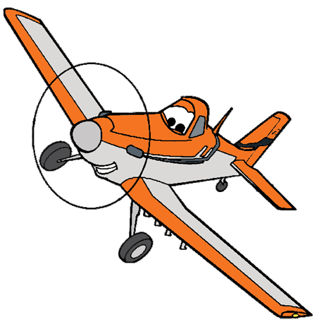



I-269

I-269

205

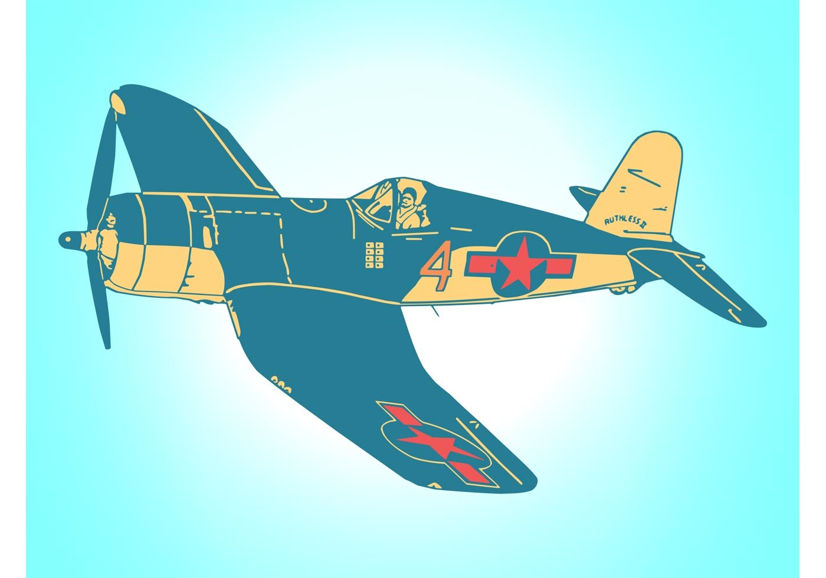



Warren Rd

Fayette County Airport

1075 Airport Rd

Somerville TN

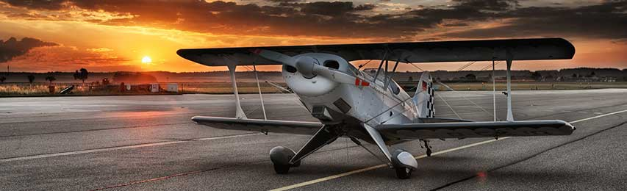

Hwy 64

Hwy 64

Airport Rd

195

193

193

Houston Levee Rd

Macon Rd

Raleigh Lagrange