Montana Grill

1740 Scottsville Rd

270-746-9746

Fairway St

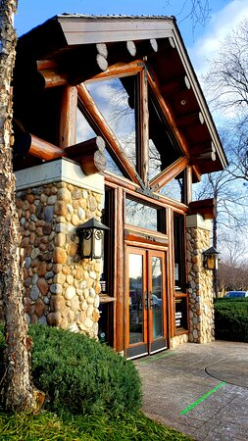

231 Scottsville Rd

231

Exit 22

Ashley St

Pascoe Blvd

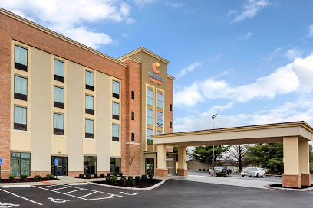

Comfort Suites

1211 Kenilwood Way

270-632-0455

Kenilwood Way

Cracker Barrel

1960 Mel Browning ST

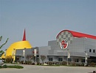

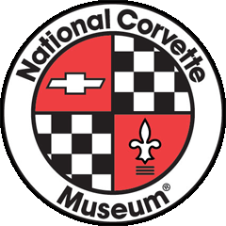

National Corvette Museum  
350 Corvette Dr.  
Bowling Green, KY 42101

**Phone:** 270-781-7973

**Itinerary**

**Thursday 9/2**

Drive to Bowling Green

Pick up Registration materials

Excursions/Classroom

Dinner

**Friday 9/3**

Laps am/pm

Excursions/Classroom

Dinner – Federal Grove B&B

**Saturday 9/4**

Check out of hotel

Drive home

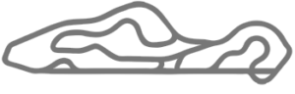



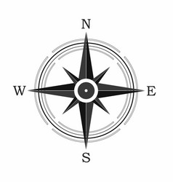



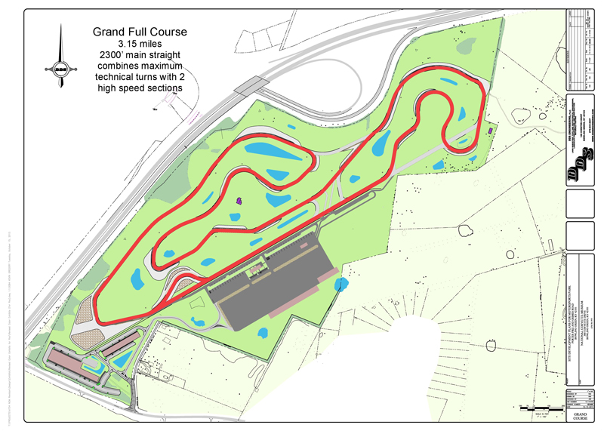

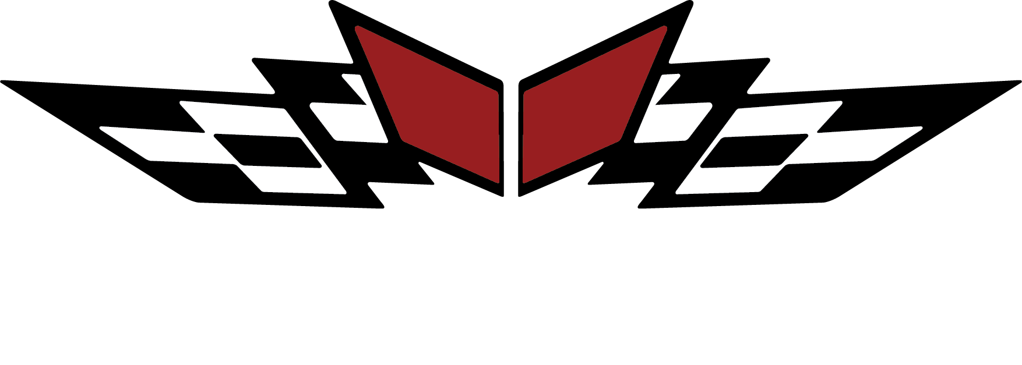

**NCM MOTORSPORTS PARK  
505 KIMBERLEE A. FAST DRIVE  
BOWLING GREEN, KY 42103**

I-65

Exit 28

Corvette Drive

I-40

I-40

2021 NCM 27th Anniversary

Thursday 9/2– Saturday 9/4

**National Corvette Museum**

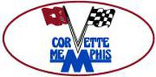

I-65

269