Tentative events currently

June 3-5, 2022 Huntsville, AL

**Vets with Vettes and Corvette Owners**

**Driving to Huntsville**

Meet at Shell Station – 5337 Hwy 72 at 7:00am

Leave at 7:30am

Get on Hwy 72 heading east

Pit Stop Exxon Station 6220 US 72 Cherokee, AL

Back onto Hwy 72 east

Get off 72/565 at Exit 15

Follow Tranquility Base to US Space & Rocket Ctr

Old Railroad Bed Rd

Blake Bottom Rd NW

Exxon

Exit 15

Jim Hornaday’s

2683 Old Railroad Bed Rd

Harvest AL

Nick Davis Rd

Jeff Rd

Research Park Blvd NW

Governors W

565

72

One Tranquility Base Huntsville, AL 35805

(256) 837-3400 Admission $25

www.rocketcenter.com



Shell

302 Goodman Rd

Poplar Ave

Houston Levee Rd

72

[**U.S. Veterans Memorial Museum**  
Promoting the Accomplishments of American Servicemen and Women](https://memorialmuseum.org)

[www.memorialmuseum.org](http://www.memorialmuseum.org) $4 donation

Open til 4pm (256) 883-3737



**Itinerary**

**Friday** – Drive to Huntsville 7:30am

Visit Museum

Check-in to Hampton I/S

Visit Jim Hornaday’s Garage

Dinner

**Saturday** – Cabela’s for car show

US Veterans Memorial Museum

Dinner

**Sunday -** Drive home

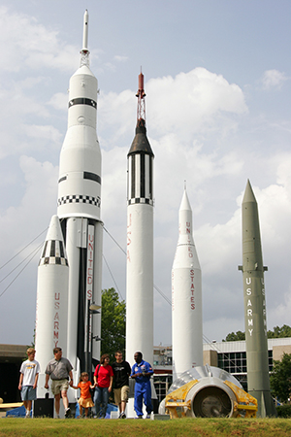

Airport Exit

231

**Cabela’s**

7090 Cabela Dr NW,

Huntsville, AL 35806

Ph. 256-517-7200





Cabella Drive

565

Tranquility Base

Madison Pike

Madison Pike

AL 255

AL 255

269

269

385

**Hampton Inn & Suites Huntsville/Research Park Area**

7010 Cabela Drive , Huntsville, Al 35806

Ph. 256-971-1850

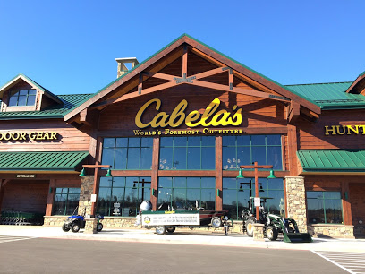

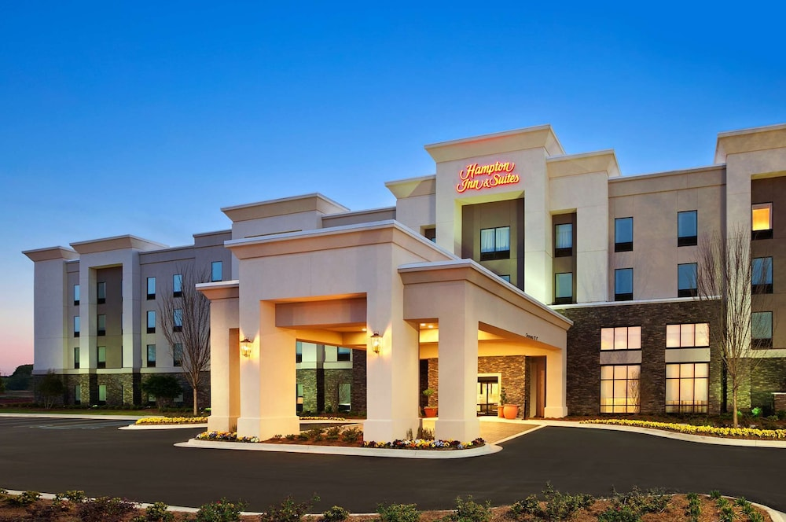

**Hampton Inn and Suites**

**7010 Cabela Drive,**

**Huntsville, AL 35806**

**TEL: +1-256-971-1850**