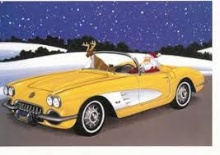
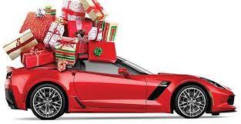
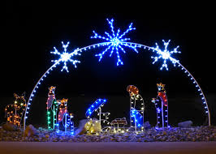
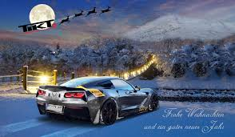
Corvette Memphis Christmas Party

CMC Christmas Party
  - December 17, 2022
Dinner Buffet - Menu
Memphis National Country Club
December 17, 2022, from 6:30 to 10:30 PM
Starters
Jumbo Shrimp Cocktail - Jumbo Shrimp served ice cold with Cocktail Sauce
Charcuterie - A beautiful display of Cured Meats, Cheeses, Fruits, Breads and Garnishes
Smoked Salmon Canapes with Fresh Dill
Entrees
Prime Rib w/au jus
Chicken Cordon Bleu
Side dishes
Garlic Mashed Potatoes
Roasted Vegetable Medley
Dessert
Fruit Cobbler a la Mode
Warm Bread Pudding with Bourbon Caramel Sauce
Beverages - Cash Bar

Price $40.00 per person

