**[U.S. Veterans Memorial Museum](https://memorialmuseum.org)** [Promoting the Accomplishments of American Servicemen and Women](https://memorialmuseum.org)

[www.memorialmuseum.org](http://www.memorialmuseum.org) $4 donation

Open til 4pm (256) 883-3737

One Tranquility Base Huntsville, AL 35805

(256) 837-3400 Admission $25

www.rocketcenter.com



**Vets with Vettes and Corvette Owners**

June 4-6, 2021 Huntsville, AL

**Itinerary**

**Friday** – Drive to Huntsville 7:00am

Check-in to Hampton I/S

Go to US Space & Rocket Ctr - lunch

Visit Jim Hornaday’s Garage

Dinner

**Saturday** – Cabela’s for car show

US Veterans Memorial Museum

Dinner

**Sunday -** Drive home



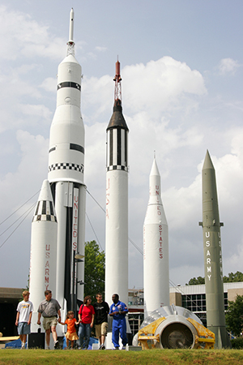

Airport Exit

231

**Cabela’s**

7090 Cabela Dr NW,

Huntsville, AL 35806

Ph. 256-517-7200

Meet at Macy’s – Carriage Crossing Mall 7:00am

Leave at 7:15am

Get on 385 East – Exit onto 72

Pit Stop 1

Pit Stop 2

Get off 72/565 at Exit 14. Stay right onto AL 255 N

Exit onto Madison Pike going west.

Left on Govenor’s W, then right onto Cabella Dr.





Govenor’s W

Cabella Drive

565

Tranquility Base

Madison Pike

Madison Pike

AL 255

AL 255

Exit 14

565

72

269

269

Carriage Crossing Mall

385

Houston Levee Rd

**Hampton Inn & Suites Huntsville/Research Park Area**

7010 Cabela Drive , Huntsville, Al 35806

Ph. 256-971-1850

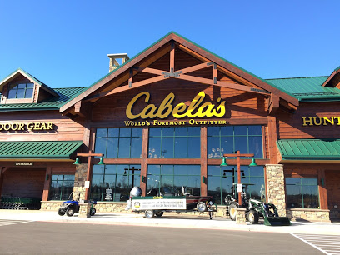

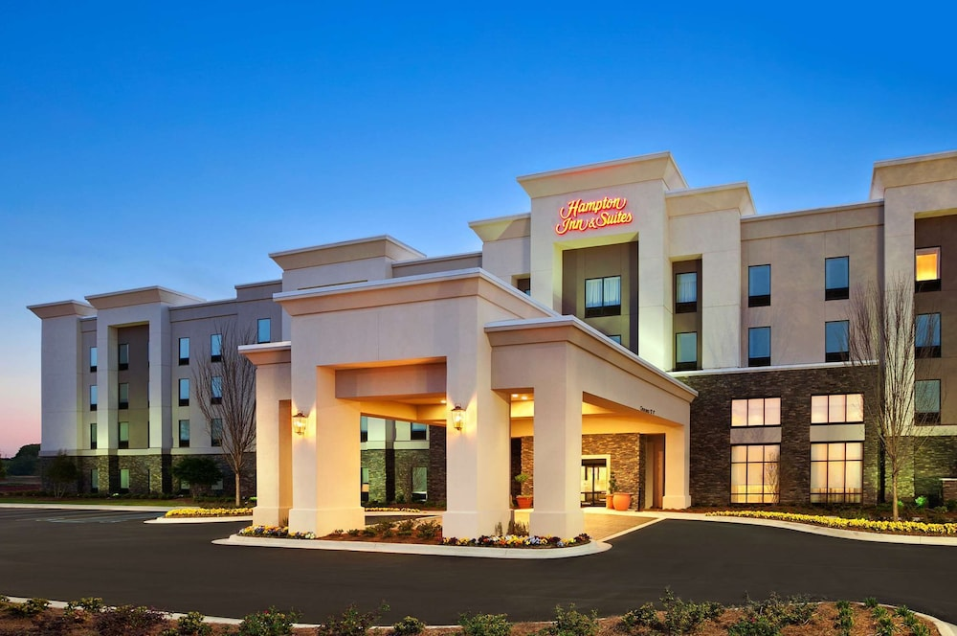

**Hampton Inn and Suites**

**7010 Cabela Drive,**

**Huntsville, AL 35806**

**TEL: +1-256-971-1850**