To Talladega Superspeedway

Take 20 to AL 77, exit 168, turn right

At Speedway Blvd, turn left to track

**To Hotel:**

385 East to 269 South

Exit 269 onto 22/78 East

Exit 22 East onto 65 South

Exit 65 onto 20 East

Stay on 20 to exit 144B (US 411 N/Moody Pkwy)

Take loop to Moody Pkwy going north

Turn right on Village Pkwy keep right onto

Village Drive to hotel

**Itinerary**

**Saturday 10/2** Drive to hotel

Racetrack events - lunch

Dinner

**Sunday 10/3** Race Day

Be at track 8:00am

Talladega Garage Experience

Yellawood 500 event

**Monday 10/4** Drive home



Comfort Inn/Suites

1951 Village Drive

205-640-6600

**October 2-4, 2021**

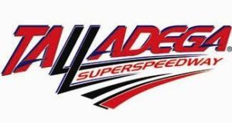

Village Drive

20

65

Moody Pkwy

Exit 144 B

20

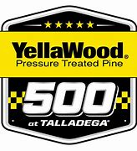

Talladega

Superspeedway



20

AL 77

Exit 168

Speedway

269

65

22

385